**MONTHLY TRAININGS**

Pre-Licensing

STATEWIDE

Monday Evenings 5:30-8:30 p.m.

Starts monthly (except December)

Online via Zoom

$75.00 per person

Contact Dawn for

more information

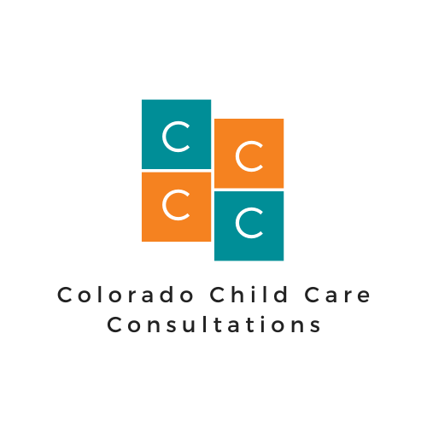

Consistent

Informative

Comprehensive

1st Aid/CPR

Metro/NOCO

Third Saturday 8 a.m.-Noon

Testing scheduled for p.m. in person

Starts monthly (except December)

Online via Zoom

$50.00 per person

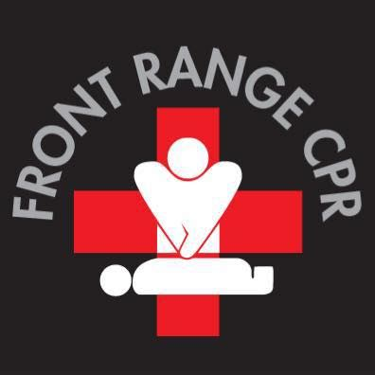

[www.CoChildCareConsultations.com](http://www.CoChildCareConsultations.com) 720-862-6253