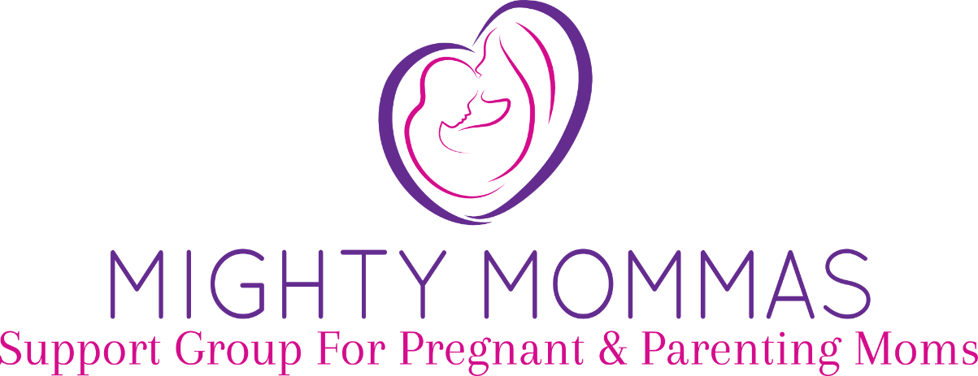

MIGHTY MOMMAS is a warm and welcoming mom-led support group for pregnant and parenting mothers. Come join other moms for sharing, laughter, snacks, public outings, and arts & crafts. Babies and young children are always welcome.

FIRST TUESDAY OF EVERY MONTH: 1:00pm-2:30pm
WHERE: Group Leader’s Home - Call for Location
STARTING: March 2016
COST: FREE

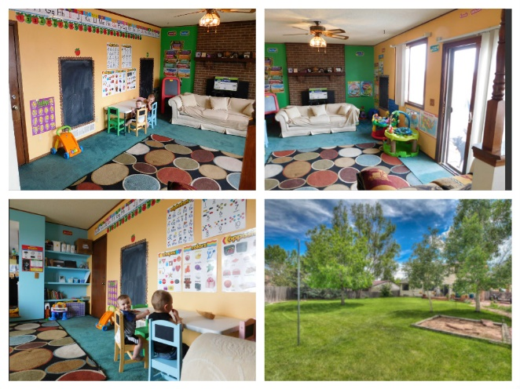

Support groups bring people together facing similar issues. In this case, group members will all be pregnant and parenting women. This group is a great opportunity to meet other moms, share experiences, share joys/challenges of motherhood, learn parenting tips, and do arts & crafts. Getting together with other moms in similar situations can make one feel less alone. Group members will create a safe and caring space by agreeing to confidentiality, acceptance, and supportive attentiveness.

Call Shannon at 720-763-1080 for more information

Facebook Page – https://www.facebook.com/mightymommasdenver

