FREE Basic Medical Care

Are you UNINSURED and need medical

For more information or to schedule your appointment:
Call: Rosanna Ledezma
rosanna@growinghome.org
(303) 895-5590

Location: Growing Home Clinic
3489 W. 72nd Avenue
Westminster, CO 80030
Suite: 107

Clinic Dates & Hours:
2nd and 4th Wednesday of every month 6:00-8:00pm

care?

Red Rocks Community College
Physician Assistant Program and
Centura Health have teamed up with
Growing Home to provide you general
health visits!

We can see anything you would see at
your family doctor for free!

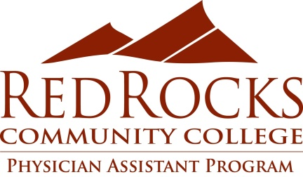
Cuidado medico basico GRATIS

No tiene seguro y necesita atencion

Para mas informacion o para programar su cita:
Llamar: Rosanna Ledezma
rosanna@growinghome.org
(303) 895-5590

Ubicacion: Clinica de Growing Home
3489 W. 72nd Avenue
Westminster, CO 80030
Suite: 107

Fechas y horarios de la clinica:
Segundo y cuarto miercoles de cada mes 6:00-8:00pm

medica?

El programa de asistentes medicos de
la comunidad de Red Rocks y
Centura Health se han unido con
Growing Home para proveer
Visitas generales de salud!

Podemos atender todo lo que verias
con tu doctor de familia GRATIS!

