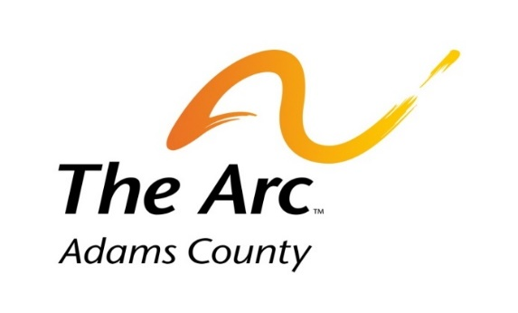
Families and Special Education in Adams County

Join us for...

Families are welcomed to join our informal monthly gathering to discuss and share information/topics related to children with special needs. Coffee and Conversation will be the second Tuesday of every month from 9:00 to 11:00 AM at The Arc of Adams County office. The first hour will provide specific information regarding special education and Individual Education Programs (IEP’s). The second hour provides a wonderful opportunity to ask questions and network with other parents. Refreshments will be provided.

(Children are welcome; however, we are unable to provide child care or child supervision).

Upcoming Dates: February 14, March 14, April 11, May 9

641 E. 112th Ave, Northglenn 80233
303-428-0310

