Care Coordination and the Medical Home Approach
- The Medical Home Approach
The Medical Home is a team approach to healthcare that focuses on providing comprehensive and cost-effective patient- and family-centered care. It ensures that care is organized across systems using open and proficient communication with the patient/family, providers, and other individuals supporting the patient’s/family’s welfare.
- Care Coordination
According to Antonelli, McAllister, and Popp (2009), developers of the “Framework for High-Performing Pediatric Care Coordination,” the defining characteristics of care coordination are as follows:
- Patient- and family-centered
- Proactive, planned, and comprehensive
- Promotes self-care skills and independence
- Emphasizes cross-organizational relationships
Furthermore, several care coordination competencies are recommended, including the development of partnerships, integration of resource knowledge, and management/tracking of tests, referrals, and outcomes (Antonelli, McAllister, and Popp, 2009).
- Strategies and Benefits of Implementing Care Coordination and the Medical Home Approach
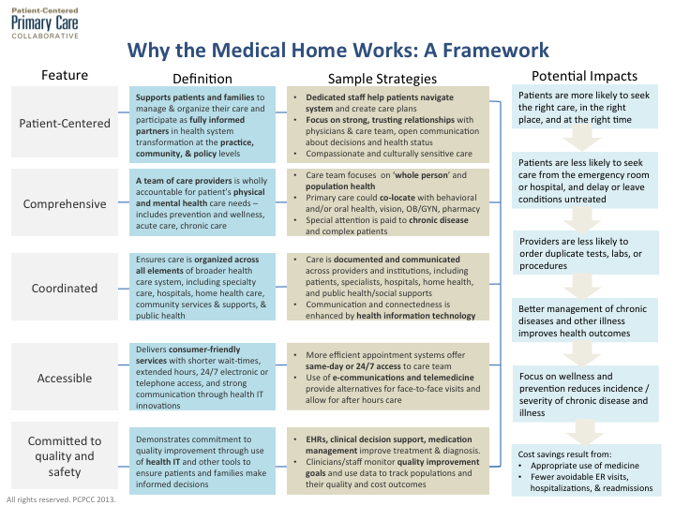
Patient-Centered Primary Care Collaborative, 2013

